A small magic dice problem
Yue Kwok Choy

This is a nice dice problem sent to me by Kwok Wah, an old QC boy. It is quite interesting and I like to share this with junior boys.

There is a magic toy, of a set of 5 dices. On the six faces of the dices they have the following set of numbers:
Dice 1: 384, 780, 186, 483, 681, 285
Dice 2: 377, 179, 872, 278, 773, 971
Dice 3: 564, 366, 762, 663, 168, 960
Dice 4: 459, 756, 954, 657, 855, 558
Dice 5: 741, 642, 345, 840, 147, 543

They are actually for a magic trick, by randomly throwing the dice, selecting 1 of the numbers on each of the dice, the host can quickly get the sum of these 5 numbers by the following procedure:
1. take the unit digit of the 5 numbers out
2. calculate the sum of these 5 digits
3. calculate 50 – answer worked out in step 2
4. the answer in step 2 should be the rightmost 2 digits of the sum of 5 numbers and the answer in step 3 would be the leftmost 2 digits of the sum of 5 numbers.

For example,
If the 5 numbers from the dice chosen are: 741, 366, 780, 558, 278 .
then :
- their unit digits are 1, 6, 0, 8, 8
- sum of them = 1 + 6 + 0 + 8 + 8 = 23
- 50 –23 = 27
- So the sum of the 5 numbers would be 2723 .
You can verify with other sets of numbers.

Can you figure out why these dices can work?
You may scroll to the bottom of next page to check after investigation.

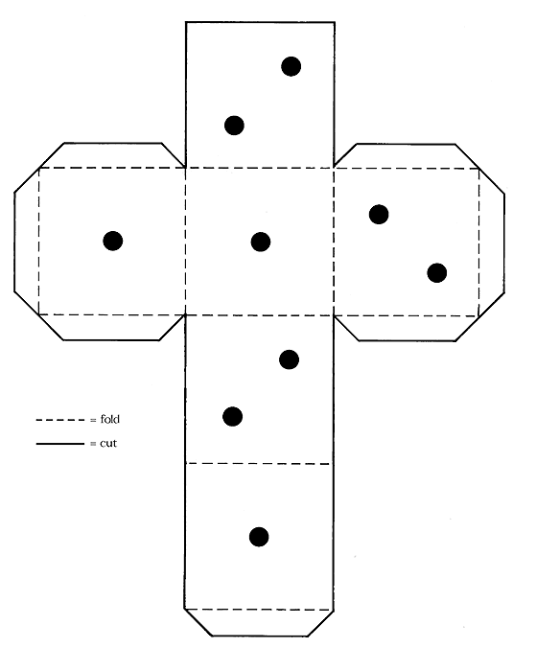
Scroll down please.

Brief explanation of the dice problem:

(1) Obviously the sum of rightmost digits of 5 numbers is between 10 and 99.
(2) The tenth digit of any number in dice n is fixed with values (8, 7, 6, 5, 4) and the sum 8 + 7 + 6 + 5 + 4 = 30.
(3) The sum of unit and hundredth digit of any number of dice n is also fixed with values (7, 10, 9, 13, 8) and the sum 7 + 10 + 9 + 13 + 8 = 47.
(4) By (2), observe 30 (with a 0), therefore sum of rightmost digits of 5 numbers should be the unit and tenth digits of the sum of the 5 numbers.
(5) Also by (3), 47 add to the 3 in the 30 of (2) should be 50. Using this 50 to subtract the sum of the unit digits should therefore gives the leftmost two digits of the sum of the 5 numbers.

Exercise
- Make 5 paper dices using the given numbers and play the game.
- Can you design your dices using other numbers ?

